Earth magnet

A compass shows explorers which way is north.
The needle on a compass is a magnet that is free to turn.
The needle always turns to point north.
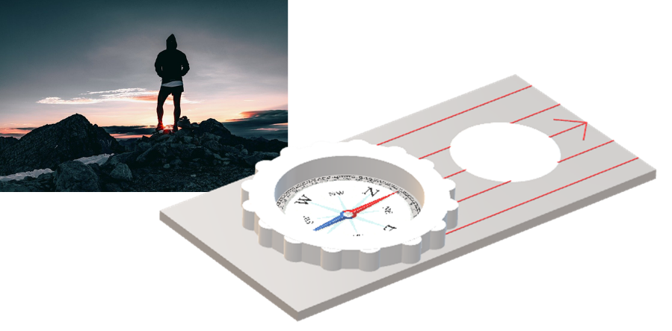
Some students are discussing why a compass needle always points north.
Grace: The north-seeking-pole of the Earth’s magnet is at the North Pole.
Freya: The north-seeking-pole of the compass needle is pulled towards the North Pole.

Hannah: The nearer to the North Pole, the stronger the magnetic pull.

Jessica: The Earth is a giant magnet.

Isabella: Gravity pulls magnetic objects toward the North Pole.

To answer
- Who is right about why a compass needle always points north?
  - Explain your answer
- Who is wrong about why it points north?
  - What would you say to help them understand?

Cards for  Earth magnet | Freya: The north-seeking-pole of the compass needle is pulled towards the North Pole.
Grace: The north-seeking-pole of the Earth’s magnet is at the North Pole. | Hannah: The nearer to the North Pole, the stronger the magnetic pull.
Isabella: Gravity pulls magnetic objects toward the North Pole. | Jessica: The Earth is a giant magnet.

Cards for  Earth magnet | Freya: The north-seeking-pole of the compass needle is pulled towards the North Pole.
Grace: The north-seeking-pole of the Earth’s magnet is at the North Pole. | Hannah: The nearer to the North Pole, the stronger the magnetic pull.
Isabella: Gravity pulls magnetic objects toward the North Pole. | Jessica: The Earth is a giant magnet.

Physics > Big idea PEM: Electricity and magnetism > Topic PEM3: Magnets and electromagnets > Key concept PEM3.1: Magnetic fields
Response activity
Earth magnet

Overview
Learning focus: | The magnetic field around a magnet can be represented by field lines, which indicate the size and direction of the force of the magnet on the north-seeking-pole of another magnet.
Observable learning outcome: | Compare the magnetic fields of different magnets, in order to predict the properties of the magnets.
Activity type: | Talking heads
Key words: | Magnetic field, magnetic field lines, attract, repel, north-seeking-pole

This activity can help develop students’ understanding by addressing the sticking-points revealed by the following diagnostic question:
- Diagnostic question: Different fields
What does the research say?
There has been little research on students’ abilities to plot or interpret patterns of magnetic field lines around bar magnets. Often magnetic field patterns are presented as lines of force and shown as arrows pointing away from the north-seeking-pole and towards the south-seeking-pole. The force of the magnet on a magnetic object is described as bigger where the lines are closer together. This description is confusing in several ways and needs unpicking carefully with students. More accurately, magnetic field lines show the direction in which the north-seeking-pole of a magnet would be pushed or pulled.
When interpreting magnetic fields, the idea that the field is stronger where the field lines are closer together makes no sense to many students. The way students typically plot magnetic fields, with small ‘plotting’ compasses, allows them to add extra field lines at any point in a magnetic field pattern to make the field lines closer together at this point. This suggests that adding field lines makes the magnet stronger! The new field line however, will be closer to adjacent field lines at some points and further away from them at other points. Without accurate measurement of magnetic field strengths, magnetic field patterns can only give an indication of the relative strengths of different points in a magnetic field and the strengths of two different magnetic fields cannot be compared.
In a study, of 56 trainee science teachers and 16 primary science teachers, Hickey and Schibeci (Hickey and Schibeci, 1999) found some confusion over whether magnetism and gravitation are the same thing, or if they are connected in some way. A few of their sample described gravity as ‘the Earth’s magnetism’, with some noting that gravity attracts objects to the centre of the Earth and that magnetism attracts objects to the Earth’s poles. With magnets having north and south poles (sic), connections were made between the properties to the Earth and the properties of a magnet.

Ways to use this activity
This task is intended for discussion in pairs or small groups. It can be done as a pencil and paper exercise or projected onto a screen.
Students should read the statements and follow the instructions on either the worksheet or the PowerPoint. Listening in to the conversations of each group will often give you insights into how your students are thinking. Each member of a group should be able to report back to the class.
Feedback from each group can be used, with careful teacher questioning, to bring out a clear description or explanation of the science.
Differentiation
The quality of the discussions can be improved with a careful selection of groups; or by allocating specific roles to students in the each group. For example, you may choose to select a student with strong prior knowledge as the scribe, and forbid them from contributing any of their own answers. They may question the others and only write down what they have been told. This strategy encourages contributions from more members of each group.
Expected answers
Freya, Hannah and Jessica are correct. The Earth is essentially a giant magnet and it has a magnetic field pattern that is the same as that of a bar magnet, with its south-seeking-pole at the North Pole*. The nearer to the North Pole, the stronger the magnetic field is – just like it is with a bar magnet.
Grace thinks what a lot of people do, that the north-seeking-pole of the Earth’s magnetic field is at the North Pole. This is probably because ‘north-seeking-pole’ is often shortened to ‘north pole’, which is the same as ‘North Pole’! The north-seeking-pole of a compass needle would however, be repelled by a north-seeking-pole and if there was one at the North Pole, it would make a compass needle point away from the North Pole.
Isabella is mixing together ideas about gravity and magnetism. Any object with mass has a gravitational field that attracts any other object that has a mass. A magnetic field around a magnet attracts only objects that are magnetic and it both attracts and repels different parts of other magnets. Gravitation and magnetism are caused by different things and the properties of each field are different. They are not the same as each other.
*The magnetic pole is actually up to several hundred kilometres from the true North Pole and moves around at a rate of tens of kilometres each year.
Acknowledgments
Developed by Peter Fairhurst (UYSEG).
Images: Peter Fairhurst (UYSEG); explorer photograph: https://pixabay.com/photos/hiker-hiking-sunrise-outdoor-sky-1082297/; compass face: https://pixabay.com/vectors/compass-direction-navigation-travel-1299559/
References
Hickey, R. and Schibeci, R. A. (1999). The attraction of magnetism. Physics Education, 34, 383-388.

